SOUTHERN REGIONAL PLANNING PANEL

COUNCIL ASSESSMENT REPORT

Panel Reference | PPSSTH-273
DA Number | RA23/1001
LGA | Shoalhaven City Council
Proposed Development | The demolition of existing structures, construction of hotel accommodation, food and drink premises (pub) and associated works.
Street Address | 124, 130 & 132 Island Point Rd, St Georges Basin – Cooee Hotel
Applicant/Owner | L Carmichael & L.C Hawke (Applicant  St Georges Basin Holdings Pty Ltd (Owner)  Shoalhaven City Council (Owner)
Date of DA lodgement | 1 August 2023
Number of Submissions | The application was publicly exhibited in accordance with the requirements of the Environmental Planning and Assessment Regulations 2021 from 9 August 2023 to 6 September 2023, with a further extension to 20 September 2023. Eight (8) submissions to the development were received during the notification period, of which five (5) are objections.  Following receipt of further information, the Development Application was notified for a second time between 31 January 2024 and 28 February 2024. 4 submissions were received during this notification period.
Recommendation | Approval subject to conditions
Regional Development Criteria (Schedule 6 of State Environmental Planning Policy (Planning Systems 2021) | Capital Investment Value (CIV) exceeds $5 million for Council related development ($7,869,158.00)
List of all relevant s4.15(1)(a) matters | - Environmental Planning and Assessment Act 1979  - Environmental Planning and Assessment Regulation 2021  - Rural Fires Act 1997  - Biodiversity Conservation Act 2016  - State Environmental Planning Policy (Planning Systems) 2021  - State Environmental Planning Policy (Resilience and Hazard) 2021  - State Environmental Planning Policy (Transport and Infrastructure) 2021  - Shoalhaven Local Environmental Plan 2014  - Shoalhaven Development Control Plan 2014
List all documents submitted with this report for the Panel’s consideration | - Internal and External Response  - DCP Compliance Assessment  - Recommended Conditions of Consent  - NSW RFS Concurrence  - Amended Architectural Plans  - Amended Landscape Plan  - Amended Civil Engineering Plans  - Amended Statement of Environmental Effects  - Amended Traffic and Parking Statement  - Applicant’s Clause 4.6 Variation Request
Report prepared by | Jeremy Swan, The Planning Hub – Independent Town Planning Consultant on behalf of Council
Report date | 26 May 2025

Summary of s4.15 matters  Have all recommendations in relation to relevant s4.15 matters been summarized in the Executive Summary of the assessment report? | Yes
Legislative clauses requiring consent authority satisfaction  Have relevant clauses in all applicable environmental planning instruments where the consent authority must be satisfied about a particular matter been listed, and relevant recommendations summarized, in the Executive Summary of the assessment report? | Yes
Clause 4.6 Exceptions to development standards  If a written request for a contravention to a development standard (clause 4.6 of the LEP) has been received, has it been attached to the assessment report? | Yes
Special Infrastructure Contributions  Does the DA require Special Infrastructure Contributions conditions (S7.24)?  Note: Certain DAs in the Western Sydney Growth Areas Special Contributions Area may require specific Special Infrastructure Contributions (SIC) conditions | No
Conditions  Have draft conditions been provided to the applicant for comment?  Note: in order to reduce delays in determinations, the Panel prefer that draft conditions, notwithstanding Council’s recommendation, be provided to the applicant to enable any comments to be considered as part of the assessment report. | Yes

Table of Contents

1. PURPOSE OF REPORT 5
2. SUMMARY OF RECOMMENDATION 5
3. EXECUTIVE SUMMARY 5
4. BACKGROUND 6
5. THE PROPOSAL 12
6. ASSESSMENT 13
7. OTHER MATTERS 33
8. CONCLUSION 33
9. RECOMMENDATION 34

Attachments

- Internal and External Response

- DCP Compliance Assessment

- Recommended Conditions of Consent

- NSW RFS Concurrence

- Amended Architectural Plans

- Amended Landscape Plan

- Amended Civil Engineering Plans

- Amended Statement of Environmental Effects

- Amended Traffic and Parking Statement

- Applicant’s Clause 4.6 Variation Request

PURPOSE OF REPORT

The purpose of this report is to seek the Southern Regional Planning Panel’s (the Panel) determination of a development application (DA) for the demolition of existing structures, construction of hotel accommodation and a food and drink premises (pub) and associated works at 124, 130 & 132 Island Point Road, St Georges Basin.

The Panel is the determining authority for this DA as, pursuant to Part 2.4 and Schedule 6 of State Environmental Planning Policy (Planning Systems) 2021, the capital investment value (CIV) of the proposed development is $7,869,158 which exceeds the CIV threshold of $5 million and involves works on Council owned land.

SUMMARY OF RECOMMENDATION

That the Panel approve RA23/1001 for the demolition of existing structures, construction of hotel accommodation and a food and drink premises (pub) and associated works at 124, 130 & 132 Island Point Road, St Georges Basin pursuant to Section 4.16 of the Environmental Planning and Assessment Act 1979 subject to the conditions contained in this report.

EXECUTIVE SUMMARY

Council is in receipt of a DA submitted on 1 August 2023, seeking approval for the demolition of existing structures, construction of hotel accommodation and a food and drink premises (pub) and associated works at 124, 130 & 132 Island Point Road, St Georges Basin.

The Planning Hub were engaged to undertake an independent planning assessment of the application as Council are one of the landowners for the DA.

A detailed assessment of the development has been undertaken against the relevant environmental planning instruments and development control plans and the key issues with the application are:

- The proposal varies the maximum building height control for the site under the Shoalhaven Local Environmental (LEP) 2014. The applicant submitted a Clause 4.6 Variation Request which was amended (building height variation reduced) as part of the Applicant’s response to the request for further information dated 27 August 2023. The proposed variation is considered to be reasonable as outlined in this report.

- The proposal impacts on a number of trees located on Council adjoining land. A final request for additional information was issued to the applicant on 10 April 2025. The applicant did not provide the required information which included root mapping, accurate design information in respect of physical works near the trees and identification of all tree branches required to be pruned. Council’s tree officer advised that the information submitted was not supported and had not addressed the concerns raised. Council’s tree officer was asked to provide conditions of consent that address the above issues which was subsequently provided.

The applicant has not sufficiently resolved the outstanding tree issues, however it is considered appropriate that detailed conditions of consent be issued to ensure that Council’s trees are appropriately protected during construction.

- The proposed development does not comply with Council’s on-site car parking requirements for new developments. A final request for additional information was issued to the applicant on 10 April 2025. The applicant provided a further traffic and parking impact assessment, additional survey and parking data and a response from the town planner.

This additional information has been reviewed by Council’s development engineering lead who has advised that he does not support the application as insufficient on-site car parking is provided for the development. In the event the DA is approved, he was asked to provide conditions of consent. He has advised that whilst these conditions offset some of the impacts associated with the significant car parking shortfall, it does not adequately resolve the non-compliance.

Having considered the comments provided above, and weighing up the development as a whole, the benefits the development will bring to the local community, the issue is finally balanced and subject to detailed conditions from a traffic and parking perspective including the provision of an updated Plan of Management that requires the provision of a Green Travel Plan to encourage patron travel other than via private vehicle and the provision of a courtesy bus service that patrons can book via the hotel’s app, the development is supported.

Following 2 notifications of the DA, Council received a total of 7 unique objections. These comments have been responded to further in this report.

Considering the above, it is recommended that the Southern Regional Planning Panel determine the Development Application pursuant to Section 4.16(1) of the Environmental Planning and Assessment Act 1979 and grant consent subject to the to the Recommended Conditions of Consent as provided at Attachment 3.

BACKGROUND

Application Background

- DA submitted on 1 August 2023, seeking approval for the demolition of existing structures, construction of hotel accommodation and a food and drink premises (pub) and associated works at 124, 130 & 132 Island Point Road, St Georges Basin.

- The Planning Hub were engaged to undertake an independent planning assessment of the application as Council are one of the landowners for the DA.

- On 27 August 2023, a request for additional information was issued to the applicant in relation to the proposed building height variation, earthworks, the interface with the adjoining reserve, proposed staging, a plan of management, site suitability, public submissions received and an amended Statement of Environmental Effects (SEE).

- On 18 December 2023, additional information was submitted by the applicant with the following amendments proposed:

  - The extent of the proposed height variation and earthworks was reduced.
  - The interface with the adjoining reserve to the north was improved through an increased setback of 1.8m to 3m.
  - Staged construction was removed from the application.
  - Amended swept path diagrams and additional parking were provided.
  - An Acoustic Report was prepared to consider potential noise impacts on the new residential subdivision to the east of the hotel site.
  - A demolition plan was included in the architectural plan set which shows trees to be removed.
  - The buildings were repositioned to ensure that the trees within the reserve are not impacted. A revised arborist report was prepared which addresses the amended plans.
  - In relation to the issues identified concerning building over sewer / existing sewer junctions, amended plans were prepared.

- On 5 September 2024, a subsequent request for additional Information was issued to the Applicant requesting the following:

  - Consider avenues to reduce parking demand (such as a reduction in licensed floor area or the development footprint in general, removal of accommodation, etc.). Alternatively, consider other measures to limit parking demand on the site, such as incorporating capacity limits associated with the development.
  - Additional information in relation to the frequency of truck movements.
  - Amendments to the width of the car parking spaces; to increase to 2.5m, in accordance with AS2890.1.
  - Civil Engineering Plans that detail the extent of earthworks and all proposed retaining structures.
  - Provision of a detailed Operational Plan of Management.

- On 18 December 2024, additional Information was submitted by the Applicant with the following information provided:

  - Amended Plans showing additional car parking spaces and a bin storage area;
  - An updated Traffic and Parking Impact Assessment and amended plans showing amended car parking space widths of 2.5m.
  - An amended Arborist Report demonstrating that no trees on the adjoining Council reserve will be impacted by the development.
  - A Plan of Management.
  - Commentary that Civil Engineering Plans would not be provided until the Construction Certificate stage; owing to the minor extent of earthworks proposed.

- On 10 April 2025, and following a detailed review of the information provided, a final request for additional information was issued to the Applicant, requesting the following:

  - An updated Traffic and Parking Impact Assessment Report that, considers credits and the impact on on-street parking, provides more detailed survey data / patron surveys to provide a more realistic guide to what is currently occurring on the site, corrections to DCP date references, consideration of the Guide to Transport Impact Assessment, notwithstanding that it does not apply to DAs lodged prior to 4 November 2024, confirmation that the provision and use of additional on demand bus services would not result in a net increase to on-street parking.

  - Additional information to understand the impact of the proposed development on the 16 Council trees, including accurately marked up photographs of all tree branches, pruning points, along with a table of works and specifications, of all proposed tree pruning, within the crowns of Council’s trees, accurate design information for all excavation associated with the retaining walls, drainage, utility services (including fire hydrants), batters and below ground work and confined spaces required for worker safety, non-destructive root mapping along the southern boundary of Lot 10 DP1143842 to a depth of 1000mm and within the tree Protection Zones.

- On 6 May 2025, the Applicant submitted additional information with the following provided:

  - An amended Traffic and Parking Impact Assessment Report which includes a commentary on parking credits, parking surveys completed over the 2025 Easter period and confirmation that the 2024 Guide to Transport Impact Assessment does not contain any new information.
  - A Tree Protection Plan that details the Tree Protection Zone and Structural Root Zone and the location of all proposed stormwater drainage, existing sewer mains and construction methods as well as the extent of tree canopy.

- On 25 May 2025, all internal referrals were provided following a review of the additional information provided by the applicant.

The Site and Locality

The subject site is located on the eastern side of Island Point Road within St Georges Basin.

The site is commonly known as 124 & 130 Island Point Road, St Georges Basin is legally described as follows:

Lot 1 DP 785956

Lot 11 DP1143842

It is noted that the application as lodged included 132 Island Point Rd (Lot 10 DP 1143842) as they propsoed tree removal on this lot, which is owned by Council. The application as amended does not seek to remove any trees from this lot now and detailed conditions have been included to ensure trees on this property are protected.

The subject site is located within St Georges Basin on Island Point Road and located within the St Georges Basin, Village Centre.

The Cooee Hotel is located within the Village Centre in Island Point Road and is directly opposite St Georges Road. The hotel driveway is located on Island Point Road and provides access to a front and rear off-street carpark. The existing car park currently provides 40 marked parking spaces (including 2 accessible spaces) in the rear carpark along the eastern end of the Cooee Hotel and a further six (6) spaces along the site’s Island Point Road frontage.

The site has a frontage to Crowea Road to the rear of the site but has currently no vehicular access. A residential subdivision is under construction on the eastern side of Crowea Road, which extends south to Anson Street. Other uses within the village centre include an IGA.

The site’s location and context is detailed in Figures 1 and 2 below.

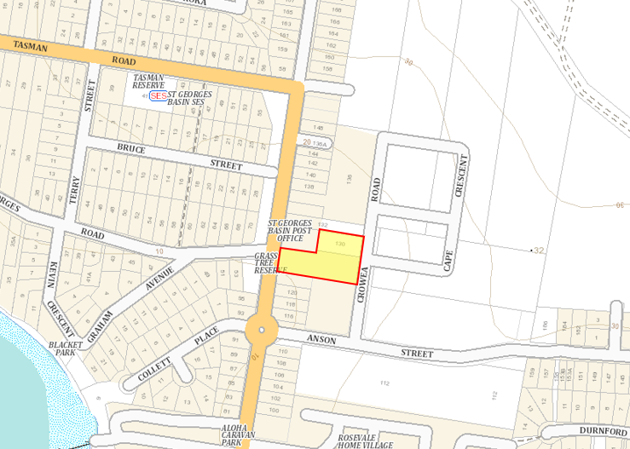
Figure 1 – Locality Plan (Source Sixmaps)

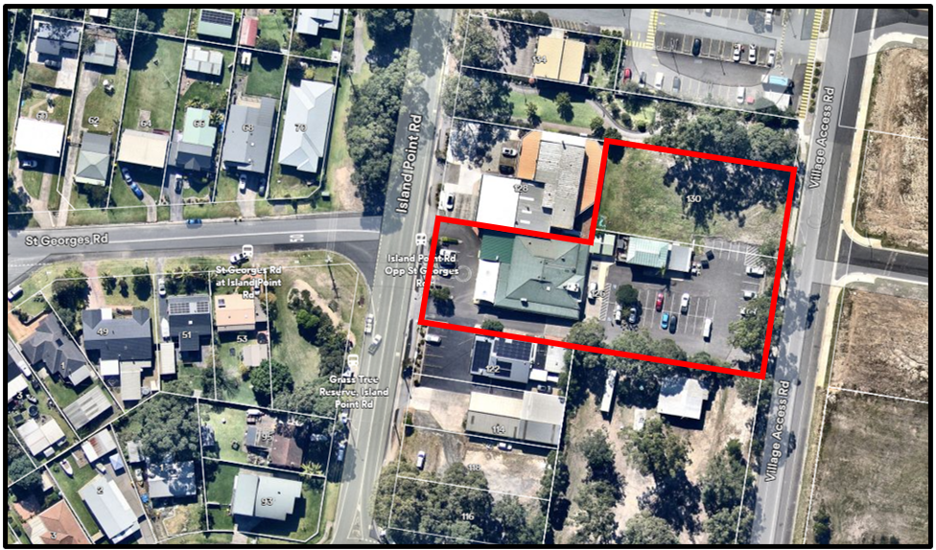
Figure 2 – Site Aerial (Source: Nearmap)

The site is zoned MU1 Mixed Use under the provisions of the Shoalhaven Local Enviornmental Plan 2014. Hotel or motel accommodation and food and drink premises are permitted with consent in the MU1 zone.

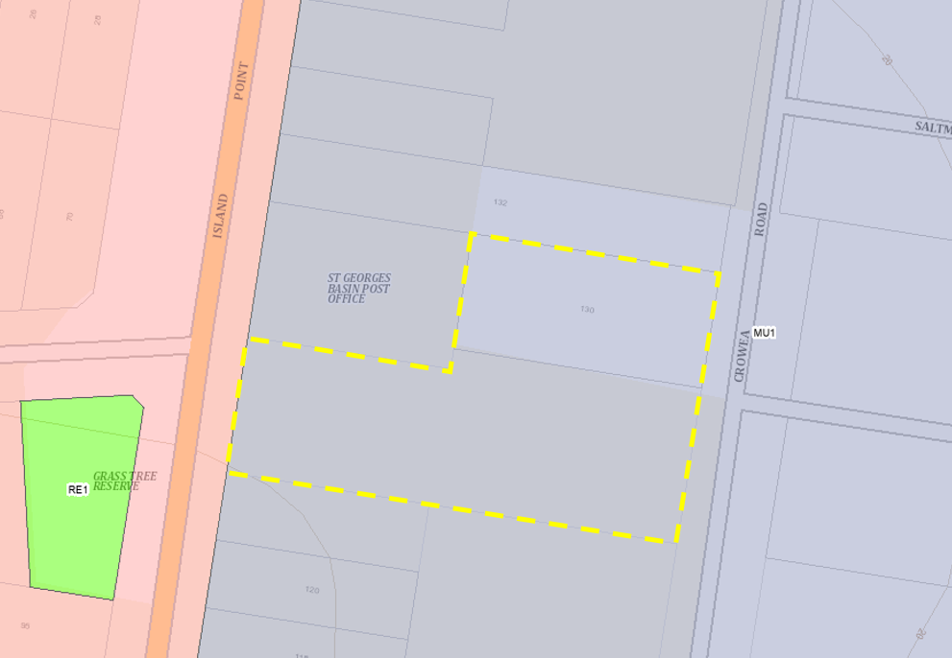
Figure 3 – Zoning Map (Source: NSW Legislation)

The Subject Application

The subject application was lodged with Shoalhaven City Council on 1 August 2023 for the demolition of existing structures, construction of hotel accommodation, a food and drink premises (pub) and associated works at 124, 130 & 132 Island Point Road, St Georges Basin.

Following a detailed assessment of the proposal, additional information was requested from the Applicant on the following dates, to ensure the development complied with the applicable development controls:

- 27 August 2023;
- 5 September 2024; and
- 10 April 2025.

Following receipt of amended information from the Applicant, the development is now in a form that enables a determination to be made.

Notification and Referrals

The subject DA is classed as Integrated Development under Clause 4.46 of the Environmental Planning and Assessment Act 1979 (EP&A Act) and was referred to the relevant authorities for concurrence, as follows:

- NSW Rural Fire Service – special fire protection purpose (tourist accommodation) proposed on bushfire prone land - NSW Rural Fires Act 1997.

In addition, the DA was referred to a number of other external authorities for comment (refer Attachment 1).

The application was publicly exhibited in accordance with the requirements of the Environmental Planning and Assessment Regulations 2021 from 9 August 2023 to 6 September 2023, with a subsequent extension to 20 September 2023. Eight (8) submissions were received during the notification period, of which six (6) are in objection to the development.

Following receipt of Further Information, the Development Application was notified for a second time between 31 January 2024 and 28 February 2024. Four (4) submissions, all objecting to the development, were received during this notification period.

THE PROPOSAL

The development application proposes the demolition of all existing structures on the site and the construction of a pub and hotel development comprising:

- Construction of a new pub building to replace the existing pub on the site, including:
  - A lower ground Plant/Storage Area;
  - Bistro and Kitchen with associated Outdoor Terrace Area and Kid’s Play Area;
  - Sports Lounge with Bar and associated Deck;
  - Gaming Room;
  - Drive-Through Bottle Shop.

- Construction of a double hotel comprising a total of 21 Rooms and an ancillary Office. Each room will accommodate up to two (2) guests, with a total maximum occupancy of 42 guests.

Both the pub and hotel are proposed to operate:

- Monday, Tuesday, Thursday and Sunday 10am – 10pm
- Wednesday, Friday and Saturday 10am to Midnight

The maximum patronage of the new pub building will be 290 people within licenced areas. The projected average peak patronage for the hotel is 127 adults on a Saturday night.

The development proposes a total of 54 car parking spaces (including 3 accessible spaces) and two (2) motorcycle parking spaces. Vehicular access is proposed to be gained via one-way Entry Only driveways off Island Point Road and Crowea Road, with all vehicles to exit the site via a one-way Exit Only driveway onto Crowea Road.

The proposal also includes installation of all required services, stormwater drainage and landscaping of the site.

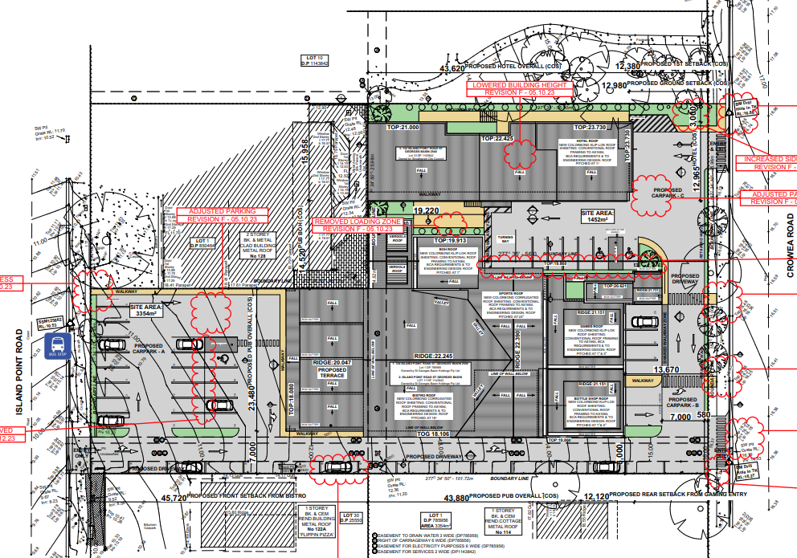
Figure 4 – Proposed Site Plan (Source: Applicant)

ASSESSMENT

An assessment against 4.15 of the Environmental Planning and Assessment Act 1979 is provided below.

Environmental Planning and Assessment Act 1979 – Section 4.15

In determining a DA, the consent authority is to take into consideration the following matters as are of relevance in the assessment of the DA on the subject property.

(a)(i) The Provisions of any Environmental Planning Instrument

The Environmental Planning Instruments that relate to the proposed development are:

- Environmental Planning and Assessment Act 1979
- Environmental Planning and Assessment Regulation 2021
- Rural Fires Act 1997
- Biodiversity Conservation Act 2016
- State Environmental Planning Policy (Planning Systems) 2021
- State Environmental Planning Policy (Resilience and Hazards) 2021
- State Environmental Planning Policy (Transport and Infrastructure) 2021
- Shoalhaven Local Environmental Plan 2014
- Shoalhaven Development Control Plan 2014

An assessment of the proposed DA against the above instruments is detailed below.

Environmental Planning and Assessment Act 1979 (EP&A Act)

Section 4.46 of the EP&A Act defines integrated development as development that requires development consent and one or more approvals under other State Government Acts. In relation to the subject application the following Acts apply:

- NSW Rural Fire Service – special fire protection purpose (tourist accommodation) proposed on bushfire prone land - NSW Rural Fires Act 1997.

NSW Rural Fire Service issued General Terms of Approval (GTA) on 24 August 2023. The GTAs have been included in the recommended conditions of consent provided in Attachment 8.

The application was also referred to the following State Government Agencies / external agencies for comment:

- Endeavour Energy; and
- Transport for NSW.

The relevant State Government Agencies / external agencies responses are summarised in Attachment 7.

Environmental Planning and Assessment (EP&A) Regulation 2021

The proposal does not contravene the Environmental Planning and Assessment Regulation.

Rural Fires Act 1997

In accordance with Section 100B of the Rural Fires Act 1997, as consent is sought to provide a special fire protection purpose (tourist accommodation) on bushfire prone land, the development is required to be referred to the NSW Rural Fire Service.

The application was referred to the NSW Rural Fire Service who raise no objection to the proposal and have issued GTA for the proposed development, these are included in Attachment 8.

Biodiversity Conservation Act 2016

The purpose of the Biodiversity Conservation Act 2016 is to maintain a healthy, productive and resilient environment for the greatest well-being of the community, now and into the future, consistent with the principles of ecologically sustainable development.

Part 7 of the Biodiversity Conservation Act 2016 sets out provisions relating to Biodiversity assessment and approvals under the Environmental Planning and Assessment Act 1979.

- For the purposes of this Part, development or an activity is likely to significantly affect threatened species if—
  - it is likely to significantly affect threatened species or ecological communities, or their habitats, according to the test in section 7.3, or
  - the development exceeds the biodiversity offsets scheme threshold if the biodiversity offsets scheme applies to the impacts of the development on biodiversity values, or
  - it is carried out in a declared area of outstanding biodiversity value.
- To avoid doubt, subsection (1)(b) does not apply to development that is an activity subject to environmental impact assessment under Part 5 of the Environmental Planning and Assessment Act 1979.

The proposed development would not likely significantly affect threatened species or ecological communities, or their habitats. The biodiversity offset scheme has not been exceeded and the subject site is not identified as an area of outstanding Biodiversity Value.

Further to the above, Section 7.3 of the Biodiversity Conservation Act 2016 sets out the relevant criteria for determining whether a proposed development or activity is likely to significantly affect threatened species or ecological communities, or their habitats. As the subject site does not contain any habitat for threatened species nor does it contain significant vegetation, the proposal is considered acceptable in this regard.

State Environmental Planning Policy (Planning Systems) 2021

In accordance with Schedule 6 Regionally Significant Development of the SEPP, the proposed development constitutes ‘Regional Development’ as it has a Capital Investment Value (CIV) of $7,869,158 which exceeds the CIV threshold of $5 million and involves works on Council owned land. The relevant consent authority for the DA is the Southern Regional Planning Panel.

State Environmental Planning Policy (Resilience and Hazards) 2021

Chapter 2 – Coastal Management

The site is mapped as being within the coastal environment area, and the provisions of Section 2.10 (Development on land within the coastal environment area) of the SEPP are applicable.

An assessment of the relevant provisions of this section is provided in the table below:

Chapter 2 Coastal Management
Relevant Provisions
Provisions | Comment
2.10 Development on land within the coastal environment area
(1) Development consent must not be granted to development on land that is within the coastal environment area unless the consent authority has considered whether the proposed development is likely to cause an adverse impact on the following—
(a) the integrity and resilience of the biophysical, hydrological (surface and groundwater) and ecological environment, | The development will not have any adverse impacts on the resilience of the biophysical, hydrological or ecological environment.
(b) coastal environmental values and natural coastal processes, | The development is sufficiently removed so as not have the potential to adversely impact coastal environmental values and natural coastal processes.
(c) the water quality of the marine estate (within the meaning of the Marine Estate Management Act 2014), in particular, the cumulative impacts of the proposed development on any of the sensitive coastal lakes identified in Schedule 1, | The site is not in proximity to any of the sensitive coastal lakes identified in Schedule 1.
(d) marine vegetation, native vegetation and fauna and their habitats, undeveloped headlands and rock platforms, | The development is sufficiently removed so as not have the potential to adversely impact any marine vegetation, or any undeveloped headlands and rock platforms. The development has been sited and designed so as not to impact native vegetation and fauna or their habitats.
(e) existing public open space and safe access to and along the foreshore, beach, headland or rock platform for members of the public, including persons with a disability, | The proposed development is sufficiently removed from the foreshore area so as not to impact existing public access.
(f) Aboriginal cultural heritage, practices and places, | The development will not impact Aboriginal cultural heritage, practices or places.
(g) the use of the surf zone. | The development will not impact the use of the surf zone.

Chapter 4 – Remediation of Land

Chapter 4 of the SEPP requires Council to consider whether the subject land of any development application is contaminated. If the land requires remediation to ensure that it is made suitable for a proposed use or zoning, Council must be satisfied that the land can and will be remediated before the land is used for that purpose.

An assessment of the relevant provisions of Chapter 4 of the SEPP (Reliance and Hazard) 2021 is provided in the table below.

Chapter 4 Remediation of land
Relevant Provisions
Provisions | Comment
4.6 Contamination and remediation to be considered in determining development application
- A consent authority must not consent to the carrying out of any development on land unless—  - it has considered whether the land is contaminated, and  - if the land is contaminated, it is satisfied that the land is suitable in its contaminated state (or will be suitable, after remediation) for the purpose for which the development is proposed to be carried out, and  - if the land requires remediation to be made suitable for the purpose for which the development is proposed to be carried out, it is satisfied that the land will be remediated before the land is used for that purpose.  - Before determining an application for consent to carry out development that would involve a change of use on any of the land specified in subsection (4), the consent authority must consider a report specifying the findings of a preliminary investigation of the land concerned carried out in accordance with the contaminated land planning guidelines. | The Applicant was requested to provide a Preliminary Site Investigation as part of the Request for Further Information to demonstrate that the site is suitable for the intended use. The Applicant has declined to prepare this investigation for the following reasons:  a. The site has been used for the purposes of a pub and no other use. A series of historical aerial photographs are enclosed which demonstrate  this. Operating a pub is not a land use that can reasonably cause site contamination.  b. There are no known land uses on adjoining land that would indicate that contamination may be an issue in the locality.  c. The Council holds no PCL (potentially contaminated land) file for the site.  d. There are no visible signs of site contamination on the land.  e. The use of the land is not changing. The pub is simply being replaced by a new pub. There has always been residential accommodation on the land.  f. Any soil excavated from the site will be tested as required by law before leaving the site.  g. The Managing Land Contamination Planning Guidelines SEPP 55– Remediation of Land (current guidelines) do not indicate that a  contamination report would be warranted in the circumstances.  Council’s Environmental Health Officer has reviewed the above and are in support of the reasoning.  Therefore, further investigation is not deemed to be required and the site is considered suitable for its continued use as a pub with associated accommodation.

State Environmental Planning Policy (Transport and Infrastructure) 2021

In accordance with Clauses 2.119 and 2.122 of the SEPP, the proposed development was referred to the Transport for NSW (TfNSW) for review and comment as the development has frontage to Island Point Road (classified regional road) and constitutes traffic generating development. TfNSW raise no objection to the DA.

Shoalhaven Local Environmental Plan 2014

The Shoalhaven Local Environmental Plan (LEP) 2014 applies to the site and proposed development.

Permissibility

The site is zoned MU1 Mixed Use under the provisions of the Shoalhaven Local Environmental Plan 2014. Within the MU1 zone, ‘pubs’ (a type of food and drink premises) and ‘hotel or motel’ accommodation are permitted with consent.

Figure 7 – Zoning Map (Source: NSW Legislation)

Zone Objectives

The objectives of the MU1 Mixed Use zone are as follows:

  - To encourage a diversity of business, retail, office and light industrial land uses that generate employment opportunities.
  - To ensure that new development provides diverse and active street frontages to attract pedestrian traffic and to contribute to vibrant, diverse and functional streets and public spaces.
  - To minimise conflict between land uses within this zone and land uses within adjoining zones.
  - To encourage business, retail, community and other non-residential land uses on the ground floor of buildings.

Officer Comment:

The proposed development is consistent with the objectives of the zone as it will provide land uses that will provide employment opportunities whilst providing a diverse and active street frontage to Island Point Road. The proposal facilitates the continued and improved use of the site as a hotel and pub at a suitable location in St Georges Basin that will enhance the activation of the area.

Relevant Clauses

The DA was assessed against the following relevant clauses of the Shoalhaven LEP 2014.

Clause | Requirement | Provided | Compliance
2.7 –  Demolition | The demolition of a building or work may be carried out only with development consent. | The application proposes the demolition of existing structures. | Yes
4.3 – Height of Buildings | The height of a building on any land is not to exceed the maximum height shown for the land on the Height of Buildings Map – 8m | The proposed development results in a variation of 1.7m (21%) pursuant to Clause 4.3 of the Shoalhaven Local Environmental Plan 2014.  A Clause 4.6 Variation Request was submitted with the application and an amended Clause 4.6 was also submitted as part of the Applicant’s Response to the Request for Further Information. The justification given is supported and is assessed below.  Refer to the discussion of the Clause 4.6 submission below. | No – Clause 4.6 Variation request submitted.
5.20 – Standards that cannot be used to refuse consent—playing and performing music | The consent authority must not refuse consent to development in relation to licensed premises on the grounds of noise caused by the playing or performance of music, if the consent authority is satisfied the noise may be managed and minimised to an acceptable level. | The Development Application is supported by an acoustic report which addresses a number of issues including how noise from music will be managed. | Yes
7.1 - Acid sulfate soils | Class 5 | The development does not involve any works within 500m of adjacent Class 1, 2, 3 or 4 land that is below 5m AHD; an acid sulfate soils management plan is not required. | Yes
7.2 –  Earthworks | To ensure that earthworks for which development consent is required will not have a detrimental impact on environmental functions and processes, neighbouring uses, cultural or heritage items or features of the surrounding land. | The proposed development involves earthworks to facilitate the proposed development. Council’s Development Engineering have assessed the proposed development and have not raised concerns in respect of the earthworks. The conditions provided by Development Engineering have been included in the Recommended Conditions of Consent provided in Attachment 3. | Yes
7.11 –  Essential Services | Development consent must not be granted to development unless the consent authority is satisfied that any of the following services that are essential for the proposed development are available or that adequate arrangements have been made to make them available when required—  - the supply of water,  - the supply of electricity,  - the disposal and management of sewage. | The site has existing connections to water supply, electricity and the sewerage network. | Yes
7.20 –Development in the Jervis Bay region | Development consent must not be granted to development in a coastal sand dune area, on a rocky headland or on a flat, well-drained area along a major creekline unless the consent authority is satisfied that there will be no significant adverse impact on the natural or cultural values of the area. | The Development Application will not have an impact on the natural or cultural values of the area. | Yes

Proposed Building Height Variation and Clause 4.6 Submission/Evaluation
The site is subject to a height control of 8m under the Shoalhaven LEP 2014, as shown below.

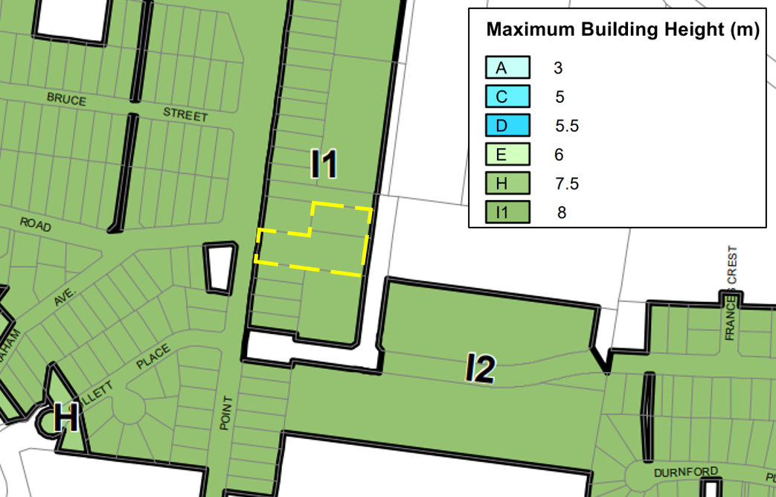
Figure 8: Height of Buildings Map (Source: Shoalhaven LEP 2014)

The hotel accommodation building has a maximum height 8.815m resulting in a variation of 0.815m (10.18%). The pub building has a maximum building of 9.7m resulting in a variation of 1.7m (21.25%) pursuant to Clause 4.3 of the Shoalhaven Local Environmental Plan 2014.

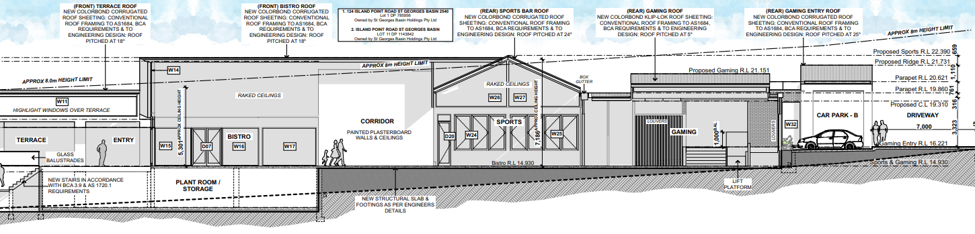
Figure 9: Section 01 Detailing Height Breach of 8m limit for the proposed Hotel (Source: ERA Architects)

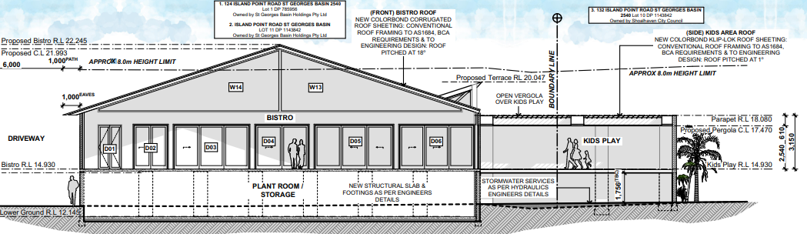
Figure 10: Section 03 Detailing Height Breach of 8m limit for the proposed Pub (Source: ERA Architects)

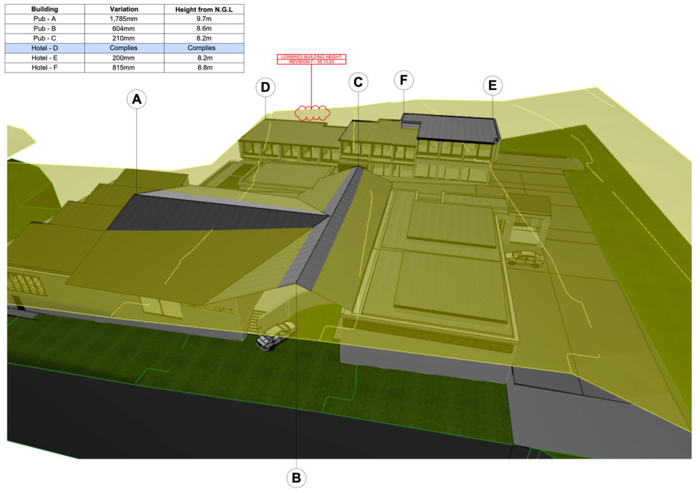
Figure 11 – 3D Height Plan showing exceedance above Height controls (Source: Applicant)

Clause 4.6 provides flexibility in applying certain Development Standards on the following grounds:

- The objectives of this clause are as follows—

  - to provide an appropriate degree of flexibility in applying certain development standards to particular development,
  - to achieve better outcomes for and from development by allowing flexibility in particular circumstances.

Pursuant to Clause 4.6:

- Development consent may, subject to this clause, be granted for development even though the development would contravene a development standard imposed by this or any other environmental planning instrument. However, this clause does not apply to a development standard that is expressly excluded from the operation of this clause.

- Development consent must not be granted to development that contravenes a development standard unless the consent authority is satisfied the applicant has demonstrated that—

  - compliance with the development standard is unreasonable or unnecessary in the circumstances, and
  - there are sufficient environmental planning grounds to justify the contravention of the development standard.

(4) Development consent must not be granted for development that contravenes a development standard unless—
(a) the consent authority is satisfied that—
(i) the applicant’s written request has adequately addressed the matters required to be demonstrated by subclause (3), and
(ii) the proposed development will be in the public interest because it is consistent with the objectives of the particular standard and the objectives for development within the zone in which the development is proposed to be carried out, and
(b) the concurrence of the Planning Secretary has been obtained.

Assessment:

Whether compliance with the standard is unreasonable and unnecessary in the circumstances of the case

The Applicant has provided justification in their written request that strict compliance with the Height of Buildings standard is unnecessary and unreasonable for the following reasons:

The way in which compliance with a development standard is established as unreasonable or unnecessary is by demonstrating that the underlying objectives of the development standard are met despite the non-compliance. However, in Wehbe v Pittwater Council (2007) NSWLEC 827, Preston J identified to four (4) other ways to establish that compliance with a development standard is unreasonable or unnecessary as follows:

(1) establish that the “underlying objective or purpose is not relevant to the development” and consequently compliance is unnecessary;
Comment: The purpose of the development standard (height limit) is relevant to the development in this instance.

(2) establish that the “underlying objective or purpose would be defeated or thwarted if compliance was required”, and therefore compliance is unreasonable;
Comment: This is not applicable as the objectives of the Development Standard remain relevant to the proposal.

(3) establish that the “development standard has been virtually abandoned or destroyed by the Council’s own actions in granting consents departing form the standard”, therefore compliance is both unreasonable and unnecessary; or Comment: This is not applicable.

(4) establish that “’the zoning of particular land’ was ‘unreasonable or inappropriate’ so that ‘a development standard appropriate for that zoning was also unreasonable or unnecessary as it applied to that land’”, and therefore compliance with the standard is unreasonable and unnecessary.
Comment: This is not applicable.

In accordance with the principle established in Wehbe, one of the ways to determine whether a Clause 4.6 variation request has demonstrated the achievement of the matters in Clause 4.6(3)(a) is to show that it is unreasonable or unnecessary to strictly apply the development standard as the development achieves the objectives of the development standard, notwithstanding the contravention of the development standard.

Demonstrating that the development achieves the objectives of the development standard involves:

1. identification of what the objectives of the development standard are; and
2. establishing that those objectives are, in fact, achieved.

The objectives of the height of building development (Clause 4.3 of SLEP 2014) and explanations of how these objectives are met are outlined in the table below:

Height – Existing character
Commercial building heights in area are 6 – 7m in height and generally read as two storey buildings. The new pub and hotel building will each read as two storey buildings at their respective street frontages. Despite the difference in height, the new buildings proposed will complement existing buildings in the area and adhere to the established two storey theme.

Height – Future Desired Character
The commercial area of St Georges Basin is unfortunately tired. It lacks a strong identity, and it needs renewal. The lack of an identity is due to a shortage of buildings featuring good design, architectural quality or prominence.

It can be reasonably expected therefore that commercial property in the area will be redeveloped soon. This is especially the case due to large subdivisions featuring land with a mixed-use business zone capable of accommodating multi-unit housing developments and residential apartment buildings being completed at present.

The future character of the area with respect to height can be expected therefore to be generally two storeys for commercial development fronting Island Point Road. It should however be acknowledged that the majority of land to the east (behind the subject site) has an 11m height limit. The desired future character for the broader locality would therefore include a mixture of 2 and 3 storey buildings.

The pub has been designed to be a new focal point for the community. A building and place where local families & friends can meet. It is a place to accommodate live music, family gatherings, birthday celebrations and a meeting place for local sporting organisations and for other special interest groups. In this respect, the proposed buildings, being slightly more prominent than what others may be (and keeping to a two storey building format) is fitting.

Given the two storey format of the building, there is no reason to believe that the future desired character of the area with respect to height will be impacted upon in any negative way.

The additional height of the pub building is within the centre of the property and well away from both street frontages. It will be imperceptible from public vantage points.

The hotel building will present as a two storey building to its street frontage. Land beyond this frontage (east of the subject land) has an 11m height limit.

Bulk and Scale – Existing Character
The new buildings will be compatible with the bulk and scale of existing development which form the current character of the area. There is a large, enclosed shopping centre within the vicinity of the site. Other buildings include large steel industrial style sheds and older two storey commercial buildings with little architectural quality.

Bulk and Scale – Future Desired Character
It is a reasonable expectation to see other commercial sites in the area be consolidated to accommodate larger replacement buildings together with associated parking in the future. The impact the new buildings will have on the future desired character of the area with respect to bulk and scale is favourable. The two storey prevailing character has been adhered to.

Visual Impacts
The new buildings will have a positive impact on the visual qualities of the built environment. There is no doubt that the local streetscape will be significantly enhanced by the development. The breach to the 8m height limit will have minimal visual impacts. The buildings for the most part sit below the 8m height limit at each respective street frontage.

Disruption of Views
Those parts of the buildings that breach the 8m height limit are not expected to impact on the ability of other property owners to retain views. Land behind the development site is in the process of being subdivided and developed by way of single storey dwellings. None of the approved dwellings nearest to the site would have a view towards the waters of St Georges Basin.

Loss of Privacy
There are no residential properties to either side of the subject land. The nearest land capable of being developed by way of residential development is separated by a public road. The land uses immediately adjoining the subject land are used for commercial purposes and are not sensitive to privacy issues.

Loss of Solar Access
Shadow diagrams have been prepared and these demonstrate that impacts on adjoining property is satisfactory on 21st of June.

It is considered that strict numerical compliance would diminish positive elements of the development. The design maximises the use of natural light, public domain integration, connectivity, accessibility and positive urban design and strict compliance would result in a reduced functionality.

The proposed variation does not result in any adverse impacts upon the amenity of adjoining properties or public domain areas. It is of a height, bulk and scale that is considered consistent with the desired future character of the locality.

The proposal has sufficient environmental planning grounds to justify contravening the development standard as demonstrated below.

Whether there are sufficient environmental planning grounds to justify contravening the development standard

The Applicant has provided justification there are sufficient environmental planning grounds to justify contravening the development standard for the following reasons:

The proposed height variation is acceptable on the site and has environmental planning merit as follows:

- Equitable access: The social welfare of the community, through provision of fully compliant disabled access to all hotel rooms and all areas of the new pub has had a large impact on the ability for the new buildings to comply with the 8m height limit. Absent the issue of needing to provide disabled access to the hotel building, the same quantity of hotel rooms could have been achieved. Exceeding the height limit is not the result of attempting to increase yield and is a pure product of providing universal access to the new tourist facility. The floor level of the pub building has been set so that disabled access is available from the main car parking area to the entry of the building. The roof structure extends westward from the main car parking area at the rear of the site where the ground level falls by over 3m for the length of the building. The elevated ground floor of the pub building at the street frontage has enabled the installation of a lift to facilitate disabled access from both car parking areas. Granted the height of the roof structure for the bistro portion of the building could be reduced to meet the 8m height limit. The breach of the height limit here is in the middle of the site away from street frontages. The height of the roof for this portion of the building has been designed to give the building a more attractive appearance and to enable more light and ventilation through it.

- Strategic Location: The proposed development is considered to be suitable for the subject site and will result in positive social and economic impacts in the locality as follows:

  - New employment and recreation opportunities will be provided to the community.
  - New up market hotel accommodation is proposed which will go towards a reduction in demand for short term residential accommodation which has been supplementing the well documented shortfall in professionally operated hotel accommodation for years. This has had an impact on the availability of permanent residential rental accommodation.
  - No additional floor space or yield has been obtained as a result of the height exceedances. The same number could have been proposed, however, disabled access wouldn’t be available to them.
  - Section 7.11 contributions payable in respect of the proposed development will contribute to the introduction of new infrastructure.
  - The proposal will stimulate the local economy through the capital investment spending on the project.

- Orderly and economic use and development of land: The proposal is representative of orderly and economic use and development of the land. The land is intended to be used for purposes that the relevant zone permits. Those parts of the building that exceed the height limit do not transform the development or proposed use of the land into something that wouldn’t reasonably be expected for the area. The format of the buildings, with respect to the number of storeys, bulk and scale are representative of existing and future desired streetscape characteristics. The quantity of floor space proposed is not excessive and the height limit breach has not resulted in any undue increases to this. The development is merely seeking to develop the land in an economical way whilst complying with relevant disabled access requirements. There may be other ways to achieve compliance here in relation to the provision of disabled access, however this would likely render the development uneconomical.

- Protection of the environment: The proposed development will not result in impacts to threatened flora and fauna, ecological communities or their habitats. The additional height proposed over and above the LEP height control does not affect these matters.

- Heritage: The site is not heritage listed nor is it situated within the proximity of any heritage listed item of conservation area.

- Good design and amenity of the built environment: The proposed development exhibits good design. The rooftop elements of the development are well thought out and have been successfully integrated into the overall design of the buildings. The elements of the buildings that breach the height limit are located away from the relevant street frontages and will not unduly impact on adjoining lands or the built environment at large. Despite the height limit breaches, the buildings will read as two storey buildings and integrate with existing development.

The consent authroity can be satisfied that the Applicant’s written request has adequately addressed the mattesr required to be demonstrated under subclause (3). The Applicant’s grounds/reasons for the proposed variations to the development standards are supported and it has been demonstrated that the devleopment is in the public interest. Given the lack of adverse impacts from a built form and amenity perspective, there are sufficient environmental planning grounds to justify contravening the standard. The concurrence of the Planning Secretary is not required to be obtained.

(a)(ii) The Provision of any Draft Environmental Planning Instrument (that is or has been the subject of public consultation under this Act and that has been notified to the consent authority that the making of the proposed instrument has been deferred indefinitely or has not been approved).

There are no draft Environmental Planning Instrument/s applicable to the proposed development.

(a)(iii) The Provisions of any Development Control Plan

Shoalhaven Development Control Plan 2014

The Shoalhaven Development Control Plan (DCP) 2014 provides detailed provisions to supplement the Shoalhaven LEP 2014. An assessment of the proposal against the relevant development controls applying to the subject site and development is provided in Attachment 2.

The proposal is generally consistent with the relevant objectives and controls of the Shoalhaven DCP 2014.

(a)(iiia) Any planning agreement that has been entered into under Section 7.4, or any draft planning agreement that a developer has offered to enter into under Section 7.4.

Not Applicable

(a)(iv) The Regulations

The Regulations do not prescribe any additional matters that are relevant to the proposed Development Application.

(1)(b) The likely impacts of the proposed development, including environmental impacts on both the natural and built environments, and social and economic impacts in the locality

Key matters for consideration when considering the development’s potential impact on the natural and built environment are deemed to be as follows:

Local s7.11 Contributions

Is the development site an “old subdivision property” identified in Shoalhaven Contributions Plan 2019? | No
Is the proposed development considered to increase the demand for community facilities in accordance with the Shoalhaven Contributions Plan 2019? | Yes - s7.11 contributions are applicable.
Is the proposed development considered to increase the demand for on water and sewer services (i.e. s64 Contributions) | Yes - See Shoalhaven Water Development Applicaiton Notice.

The development is most aptly characterised proposed ‘pub’ with area of 962.64m2 and ‘22 single bedroom hotel rooms’ development for the purpose of calculating contributions under the Plan, based upon the separate components of the overall development.

Contributions were calculated based on the area stated on the submitted plans, and number of hotel units.

Hotel

Project | Description | Rate | Qty | Total | GST | GST Incl
03AREC0005 | Planning Area 3 - Recreation facilities upgrade various locations | $328.73 | 8.80 | $2,892.82 | $0.00 | $2,892.82
03AREC3003 | Bay and Basin Leisure Centre | $492.77 | 8.80 | $4,336.38 | $0.00 | $4,336.38
03OREC0012 | St Georges Basin Village Green | $1,045.59 | 8.80 | $9,201.19 | $0.00 | $9,201.19
03ROAD2023 | St Georges Basin Village Access Road & Traffic Facilities | $9,309.98 | 8.80 | $81,927.82 | $0.00 | $81,927.82
03ROAD4021 | The Wool Road Bypass, St Georges Basin | $1,239.71 | 8.80 | $10,909.45 | $0.00 | $10,909.45
CWAREC5005 | Shoalhaven Community and Recreational Precinct SCaRP Cambewarra Road Bomaderry | $2,940.78 | 8.80 | $25,878.86 | $0.00 | $25,878.86
CWFIRE2001 | Citywide Fire & Emergency services | $162.05 | 8.80 | $1,426.04 | $0.00 | $1,426.04
CWFIRE2002 | Shoalhaven Fire Control Centre | $237.08 | 8.80 | $2,086.30 | $0.00 | $2,086.30
CWMGMT3001 | Contributions Management & Administration | $673.90 | 8.80 | $5,930.32 | $0.00 | $5,930.32
Sub Total: |  |  |  |  |  | $144,589.18
GST Total: |  |  |  |  |  | $0.00
Estimate Total: |  |  |  |  |  | $144,589.18

Pub

Project | Description | Rate | Qty | Total | GST | GST Incl
03ROAD2023 | St Georges Basin Village Access Road & Traffic Facilities | $9,309.98 | 11.13 | $103,620.08 | $0.00 | $103,620.08
03ROAD4021 | The Wool Road Bypass, St Georges Basin | $1,239.71 | 11.13 | $13,797.97 | $0.00 | $13,797.97
CWFIRE2001 | Citywide Fire & Emergency services | $162.05 | 0.83 | $134.50 | $0.00 | $134.50
CWFIRE2002 | Shoalhaven Fire Control Centre | $237.08 | 0.83 | $196.78 | $0.00 | $196.78
CWMGMT3001 | Contributions Management & Administration | $673.90 | 0.83 | $559.34 | $0.00 | $559.34
Sub Total: |  |  |  |  |  | $118,308.67
GST Total: |  |  |  |  |  | $0.00
Estimate Total: |  |  |  |  |  | $118,308.67

Car Parking

Lack of car parking is the key issue with this DA. The proposed development does not comply with Council’s on-site car parking requirements for new developments. A final request for additional information was issued to the applicant on 10 April 2025.

The applicant provided a further traffic and parking impact assessment, additional survey and parking data and a response from the town planner. This additional information was reviewed by Council’s development engineering lead who has advised that he does not support the application as insufficient on-site car parking is provided for the development. A more detailed summary of his comments is provided at Attachment 1.

In summary, Council’s DCP requires the provision of 220 car parking spaces and the application proposes 54, a significant shortfall of 166 car parking spaces.
It is noted that Council’s DCP does not provide a car parking credit where an existing development is demolished as is the case here.

The applicant states that if car parking credits are taken into account, there would be no parking shortfall. A detailed assessment of this assessment has been undertaken and whilst a credit would improve the parking deficit, it would not account for the shortfall. Our assessment is they would be entitled to a credit of 47 car parking spaces, based on the current floor areas and parking currently provided. This would still result in a shortfall of 119 car parking spaces.

In addition, the applicant has provided a transport strategy, which proposes the following additional measures to reduce the reliance on private vehicles as follows:

- Inclusion of a Courtesy bus service that includes the following features:
- 2 x 12 seat Toyota HiAce commuter vans (or similar) are to be purchased and put into service. This effectively doubles current courtesy bus capacity.
- A Cooee Hotel App will be available to download for any patron who wishes to book a courtesy bus service. The app will require users to enter their name, number of passengers, and collection address.
- Patrons wishing to leave the venue will be able to use the App or notify staff at the bar that they wish to catch the next bus departing.
- Buses are to operate at a minimum every 30 minutes on Wednesday, Thursday, Friday and Saturday between the hours of 3pm and 11:30pm.
- Buses are to operate at a minimum hourly on Sunday, Monday and Tuesday between 3pm and 11:30pm.
- Courtesy bus services will be regularly promoted to patrons using, signage throughout the hotel, emails to members providing information on improved services, announcements within the hotel using the PA system. Marketing campaigns for live entertainment will also include information on courtesy bus services.

Clause 4.15(3A)(b) of the Environmental Planning and Assessment Act 1979 requires the consent authority where a development does not comply with a DCP standard, is to be flexible in applying those provisions and allow reasonable alternative solutions that achieve the objects of those standards.

The objectives of Council’s DCP in respect of Carparking and Traffic are:

                - Ensure that adequate off street parking is provided in conjunction with development throughout the City, including any overflow parking.
                - Discourage the use of on street parking for new development.
                - Ensure that car parking areas are visually attractive, functional, operate efficiently, are safe and meet the needs of users.
                - Ensure that all vehicles enter and leave a site in forward direction and that the manoeuvring of vehicles does not take place within the road reserve, but within the subject site.
                - To encourage developments that contribute to the vitality and liveability within CBD areas.
                - Address the principles of ecologically sustainable development.
                - To ensure that the traffic and road safety implications of development are adequately assessed in accordance with current guidelines and standards.
                - To minimise any adverse traffic and road safety impacts of development.

Officer Comment

Subject to the inclusion of condition 3 as detailed below, and on balance it is considered that the proposed development satisfies the objectives of the control as follows:

- The provision of Condition 3, which includes the requirement for a green travel plan, and courtesy bus throughout the week that the proposed development will have adequate off street car parking.
- The Plan of Management is required to be updated as per Condition 3, which will ensure that the use of on street parking is discouraged.
- The redevelopment will ensure that the proposed development contributes to the vitality and liveability of the area.
- Condition 3 will ensure that traffic is minimised as a result of the proposed development.

As stated above, a draft condition of consent has been included (condition 3) which requires the Plan of Management to be updated to include the following measures:

- A green travel plan that encourages transport options other than private vehicles and encourages the use of taxi’s, uber/car share, local bus services and courtesy bus services.
- Inclusion of a Courtesy bus service that includes the following features:
- 2 x 12 seat Toyota Hiace commuter vans (or similar) are to be purchased and put into service. This effectively doubles current courtesy bus capacity.
- A Cooee Hotel App will be available to download for any patron who wishes to book a courtesy bus service. The app will require users to enter their name, number of passengers, and collection address.
- Patrons wishing to leave the venue will be able to use the App or notify staff at the bar that they wish to catch the next bus departing.
- Buses are to operate at a minimum every 30 minutes on Wednesday, Thursday, Friday and Saturday between the hours of 3pm and 11:30pm.
- Buses are to operate at a minimum hourly on Sunday, Monday and Tuesday between 3pm and 11:30pm.
- Courtesy bus services will be regularly promoted to patrons using, signage throughout the hotel, emails to members providing information on improved services, announcements within the hotel using the PA system. Marketing campaigns for live entertainment will also include information on courtesy bus services.
- The Plan of Management is to include a mechanism for yearly review of the above services.
- The Plan of Management is to include an ability to review the Plan of Management as required and is only permitted to be only varied with the approval of Council.

Subject to the above draft condition, the application on balance can be supported from a planning perspective.

(1)(c) The suitability of the site

The proposed development has adequately addressed the key concerns including built form, traffic and car parking, amenity and servicing. The proposed development is compatible with the surrounding area; therefore, Council is satisfied that the site is suitable for the proposed development.

(1)(d) Any submissions made in accordance with this Act or the Regulations.

The Development Application was advertised between 9 August 2023 and 6 September 2023. Six (6) submissions were received during the notification period objecting to the development proposal. Following receipt of Further Information, the Development Application was advertised for a second time between 31 January and 28 February 2024. Four (4) submissions were received during this notification period.

A review of the submissions received has been undertaken and a response to each key issue raised is provided below.

Objection | Response
The community has consistently objected to out-of-character over height development proposals in the village, including to the SCC, the Regional Planning Panel and the Land & Environment Court. Adjacent to the subject site, following strong objections from the community, the height limit on the undeveloped section of Anson St was reduced by SCC from a proposed 13m to 8.5m in line with all other residential zones in the village. The community remains overwhelmingly in support of maintaining the low-rise, predominately 1 and 2 storey character of buildings in our village but agrees with Council that 'minor variations may be supportable subject to suitable justification.’ | As part of the Applicants response to the Request for Further Information, the proposed hotel building has been reduced from a maximum building height of 10.6m (32.5%) to 8.8m (10%). This portion of the site is considered sensitive given it is located directly adjacent to the public reserve. The reduction is considered sufficient.  The height of the Pub building remains unchanged with a maximum height of 9.7m (21%) as part of the Applicant’s response to the Request for Further Information. As this variation relates to a portion of the pitched roof element of the building and there are no resulting environmental impacts, this variation is considered acceptable.  It is considered that the amendments made as part of the Applicants response to the Request for Further Information represents a built form that better responds to the characteristics of the site and desired future character of the area.
The development proposes a substantial retaining wall on the boundary with The Village Green which, together with the current design of the hotel component of the development, are likely to have a deleterious impact on the adjacent Village Green including the likelihood of significant damage to the canopy and roots systems of the existing trees occurring. | The proposed development has been amended as part of the Applicants response to the Request for Further Information. The Applicant has increased the setback to the site’s northern boundary from 1.8m to 3m and reduced the buildings bulk and scale. In addition, the retaining wall along the reserve boundary is no longer proposed.  Conditions of consent have been included in the Recommended Conditions of Consent provided in Attachment 3, to address tree protection.
While acknowledging that the pub is likely to provide live music entertainment, we encourage the applicant and the SCC to ensure that an acoustic management plan is in place that is sensitive its location in a residential area and minimises the impact on local residents, especially the elderly and families with children. | As part of the Request for Further Information, Councils Environmental Health Officer requested a revised Acoustic Report is to be submitted considering the sensitive receivers that are expected as part the approved subdivision. The Applicant prepared a revised Acoustic Report that considered the recently approved subdivision and Councils Environmental Health Officer deemed the proposal to be acceptable subject to the incorporation of conditions of consent which have been included in the Recommended Conditions of Consent provided in Attachment 3.
We note that the number of parking spaces proposed has been reduced from the current 46 spaces to just 41 even though a 20-room hotel and more GFA is to be added to the site. We believe that this number of parking space is inadequate and that a much larger number of spaces (we note TPH suggests 220) is required to reduce any adverse impacts of the overflow on Island Point Rd and the surrounding residential streets. | Refer to discussion on Parking in the body of this report.
Stormwater runoff from earthworks carried out on previous developments in the surrounding area has resulted in large volumes of sediments flowing into the St Georges Basin waterway causing significant damage to the marine environment. | As part of the documents originally lodged, Council’s Development Engineer deemed the concept stormwater management plan and integrated water cycle management plan to be satisfactory given the DCP requirements for detention and water quality treatment have been met. Therefore, the Applicant’s approach to stormwater runoff is considered satisfactory and conditions of consent have been imposed to ensure compliance no stormwater runoff from earthworks occurs.
The impact of the development on sewer – I would ask that Shoalhaven Water be made fully aware of the matters pertaining to sewer and stormwater piping issues. | Standard conditions of consent to manage water and sewer servicing have been included in the consent.

(1)(e) The public Interest

The public interest is served through the detailed assessment of this DA under the Environmental Planning and Assessment Act 1979, the Environmental Planning and Assessment Regulation 2021, Environmental Planning Instruments, Development Control Plan and policies.

That assessment has demonstrated that the proposed development has addressed the requirements of the relevant planning instruments and development controls applicable to it, including the objectives of the zone.

The proposed development has also demonstrated that the site is suitable for the proposal and positively contributes to the provision of services and facilities within St Georges Basin and the wider LGA. Based on the above assessment, the proposal is in the interest of the public.

OTHER MATTERS

External and Internal Referrals

The subject DA was referred to a number of public agencies and their responses are summarised in Attachment 7.

In addition, the DA was referred to a number of internal officers and their responses are summarised in Attachment 7.

Section 4.16(11) of the EP & A Act - Other restrictions on determination of development applications

The assessment process to date has been managed in accordance with Council’s adopted conflict of interest policy as required by the Act and Section 66A of the EP & A Regulation 2021.

The DA was also exhibited for 28 days, thereby satisfying Schedule 1 Clause 9B of the Act.

CONCLUSION

A Development Application has been received for the demolition of existing structures and construction of hotel accommodation, a food and drink premises (pub) and associated works at 124, 130 & 132 Island Point Road, St Georges Basin.

The development is not considered likely to have a significant and detrimental impact on the natural or built environment and is suitable for the site, having regard to its consistency with the relevant planning controls applicable to it.

RECOMMENDATION

That RA23/1001 for demolition of existing structures and construction of hotel accommodation, a food and drink premises (pub) and associated works at 124, 130 & 132 Island Point Road, St Georges Basin be approved subject to the recommended conditions in Attachment 3 to this report.

